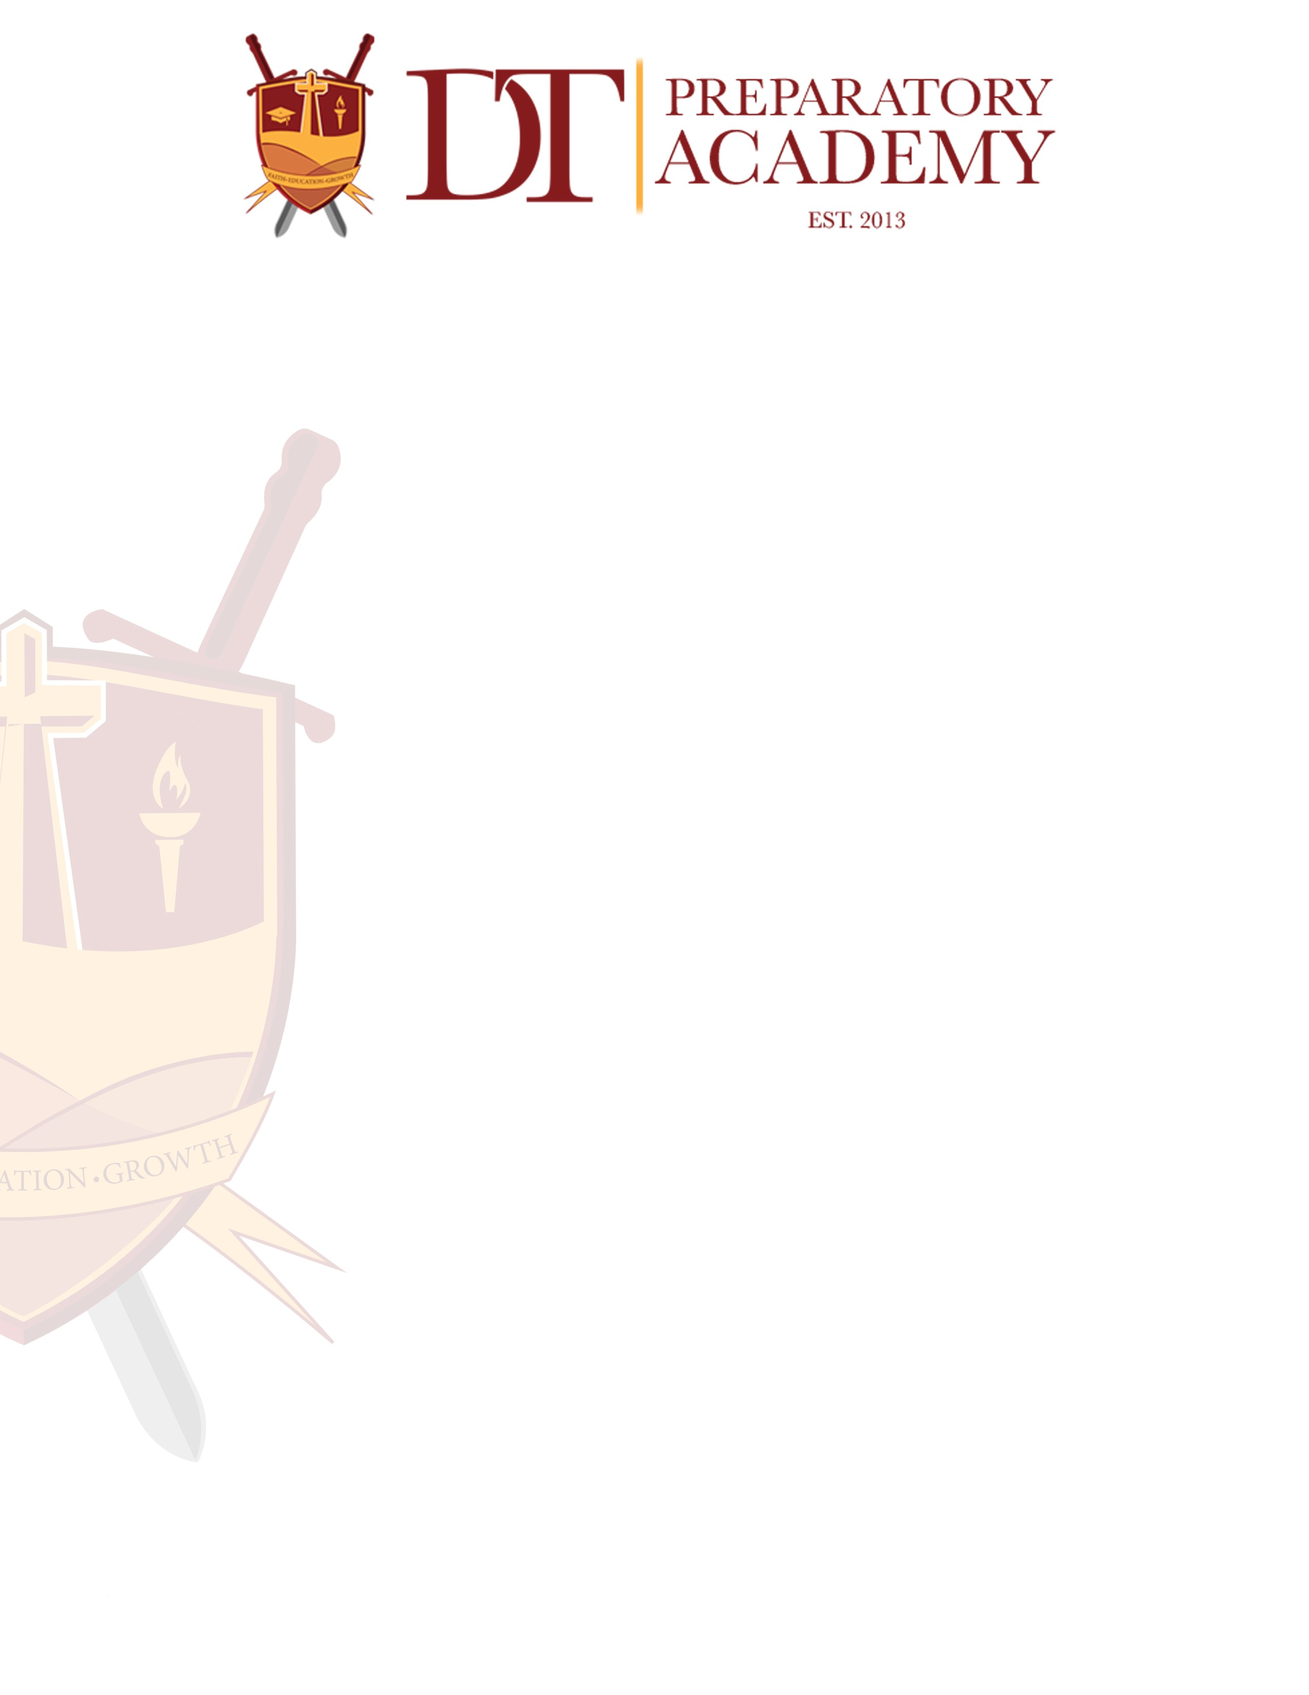
Standards of Ethical Conduct

(adapted from the Code of Ethics of the Education Profession in Florida and Principles of Professional Conduct for the Education Profession in Florida)

- Our school values the worth and dignity of every person, the pursuit of truth, devotion to excellence, acquisition of knowledge, the nature of democratic citizenship, and the inalienable rights given by God. Essential to the achievement of these standards is the freedom to learn, to teach, and to enjoy the guarantee of equal opportunity for all.
- Our primary concern is the moral conduct and the personal development of the student. Employees will therefore strive to grow professionally, practice good judgement, and maintain personal integrity in line with Biblical principles.
- Concern for the student requires that our instructional personnel:
  - Shall take reasonable effort to protect the student from conditions harmful to learning, and/or student's mental, and/or physical health, and/or sanity.
b Shall not unreasonable restrain a student from independent action in pursuit of learning.
- Shall not unreasonably deny a student access to give points of view.
- Shall not intentionally suppress or distort subject matter relevant a student’s academic program.
- Shall not intentionally expose a student to unnecessary embarrassment or disparagement.
- Shall not intentionally violate or deny a student's legal rights.
- Shall not harass or discriminate against any student on the basis of race, color, religion, sex, age, national or ethnic origin, political beliefs, marital status, handicapping condition, sexual orientation or social and family background, and shall make, reasonable effort to assure that each student is protected from harassment or discrimination.
- Shall not exploit a relationship with a student for personal gain or advantage.
- Shall keep in confidence personally identifiable information obtained in the course of professional service unless disclosure serves professional purposes or legal requirement.
- Being aware of the importance of maintaining the respect and confidence of colleagues, of students, of parents, and of the community, school employees must display the highest degree of ethical conduct. This commitment requires that our employees:
  - Shall maintain honesty in all professional dealings.
  - Shall not on the basis of race, color, religion, sex, age-, national or ethnic
origin, political beliefs. marital status, handicapping condition, if otherwise qualified, or social and family background deny to a colleague professional benefits or advantages or participation in any professional organization.
  - Shall not interfere with a colleague's exercise of political or civil rights and responsibilities.
  - Shall not engage in harassment or discriminatory conduct which unnecessarily interferes with an individual's performance of professional or work responsibilities or with the orderly process of education or which creates a hostile intimidating, abusive, offensive, oppressive environment, and further, shall make reasonable effort to assure that each individual is protected from such harassment or discrimination.
  - shall not make malicious or intentionality false statements about a colleague.

Training Requirement

All instructional personnel and administrators are required as a condition of employment to complete training on these standards of professional conduct.

Reporting Misconduct by Instructional Personnel and Administrators

All employees and administrators have an obligation to report misconduct by
instructional personnel and school administrators; which affects the health, safety, or
welfare of a student. Examples of misconduct include obscene language, drug and
alcohol use, disparaging comments, prejudice or bigotry, sexual innuendo, cheating or testing violations, physical aggression, and accepting or violating favors. Reports of misconduct or employees should be made to DT Preparatory Academy Administration or the Deliverance Tabernacle Christian Center Inc. Board of Directors or Administration.

Reports of misconduct committed by administrators should be made to Deliverance Tabernacle Christian Center Inc. Board of Directors or Administration.

Legally sufficient allegations of misconduct by Florida Certified Educators will be reported to the Office of Professional Practices Services.

Notices and procedures for reporting misconduct by instructional personnel or school administrators which affects the health, safety. or welfare of a student are posted in and on our website at www.dtprepacademy.org

Reporting Child Abuse, Abandonment or Neglect

All employees and agents have an affirmative duty to report actual or suspected cases of child abuse, abandonment, or neglect Call l-800-96-ABUSE or report online at www.dcf.state.fl.us/abuse/report

Signs of Physical Abuse

The child may have unexplained bruises, welts, cuts, or other injuries; broken bones or burns. A child experiencing physical abuse may seem withdrawn or depressed, seem afraid to go home or may run away, shy away from physical contact, be aggressive or wear inappropriate clothing to hide injuries.

Signs of Sexual Abuse

The child may have torn, stained, or bloody underwear, trouble walking or sitting, pain or itching in genital area, or a sexually transmitted disease. A child experiencing sexual abuse may have unusual knowledge of sex or act seductively, fear a particular person, seem withdrawn or depressed, gain or lose weight suddenly, shy away from physical contact, or run away from home.

Signs of Neglect

The child may have unattended medical needs, little or no supervision at home, poor
hygiene, or appear underweight. A child experiencing neglect may be frequently tired or hungry, steal food, or appear overly needy for adult attention.

Patterns of Abuse

Serious abuse usually involves a combination of factors. While a single sign may not be significant, a pattern of physical or behavioral signs is a serious indicator and should be reported.

Liability Protections

Any person, official, or institution participating in good faith in any act authorized or required by law or reporting in good faith any importance of child abuse. abandonment, or neglect to the department or any law enforcement agency, shall be immune from any civil or criminal liability which might otherwise result by reason of such action (FS. 39.203)

An employer who discloses information about a former or current employee to a prospective employer of the former or current employee upon request of the prospective employer or of the former or current employee is immune from civil liability for such disclosure or its consequences unless it is proven by clear and convincing evidence that the information disclosed by the former or current employer was knowingly false or violated any civil right of the former or current employee protected under F.S. Chapter 760. (F.S.768.095)

Derived from the FL Department of Education Ethical Standards of Conduct https://www.floridaschoolchoice.org

